**Introduction:**

In the project we are going to diagnose the brain MR images and suggesting the user that whether the given MR image has the tumor or not and classifying the image as Benign or malignant.

For implementing this we have used Convolutional Neural Network (CNN) for classification of the images in the 2 main classes i.e. Benign and malignant. We will give the input image in the Nifty format (.nii) our software will convert that file into a simple image (.png) and perform classification on that image using CNN. We have trained our CNN classifier on our training dataset and saved that classifier using .h5 file so that it will not require retraining the classifier repeatedly for each image, this will reduce the time of execution of the algorithm.

CNN(convolutional Neural Network)

CNNs, like neural networks, are made up of neurons with learnable weights and biases. Each neuron receives several inputs, takes a weighted sum over them, pass it through an activation function and responds with an output. The whole network has a loss function and all the tips and tricks that we developed for neural networks still apply on CNNs.

CNNs derive their name from the “convolution” operator. The primary purpose of Convolution in case of CNNs is to extract features from the input image. Convolution preserves the spatial relationship between pixels by learning image features using small squares of input data.

Brief intro of Brain Tumors:

Brain tumor is any mass that results from an abnormal and an uncontrolled growth of cells in the brain. Its threat level depends on a combination of factors like the type of tumor, its location, its size and its state of development. Brain Tumors can be

1. cancerous (malignant)
2. non-cancerous (benign)

Benign brain tumors are low grade, non-cancerous brain tumors, which, grow slowly and push aside normal tissue but do not invade the surrounding normal tissue. They are homogeneous, well defined and are known as non- metastatic tumors, because they do not form any secondary tumor. Whereas, malignant brain tumors are cancerous brain tumors, which grow rapidly and invade the surrounding normal tissue. Malignant brain tumors or cancerous brain tumors counted among the most deadly diseases.

**Methodology:**

Our proposed methodology is based on the CNN architecture for the classification where the classifier identifies the Brain Tumor in Brain MR Images.

The proposed methodology for classifying the brain tumors in Brain MR Images is as follows:

1. Data acquisition
2. Data preprocessing
3. Splitting of data
4. Implementation of CNN

1. Data acquisition:

According to World Health Organization, there are total 120 types of brain tumors out of which we are focusing on the two main types of tumors Low Grade Glioma (LGG) and High Grade Glioma (HGG) which is also known as Benign and Malignant respectively.

For this project, data has collected from BraTS2018 challenge. We have downloaded the data with the ground truth-values from [https://www.cbica.upenn.edu/sbia/Spyridon.Bakas/MICCAI_BraTS/2018/MICCAI_BraTS_2018_Data_Validation.zip [1](https://www.cbica.upenn.edu/sbia/Spyridon.Bakas/MICCAI_BraTS/2018/MICCAI_BraTS_2018_Data_Validation.zip%20%5b1)].

We have downloaded 285 patients real brain MR Images out of which 210 were HGG and 75 were LGG. All the images were in the sequence flair, t1, t2 and t1ce. These are the types of MR images in medical field depending on the various weighed conditions of imaging.

In total, we have downloaded 1421 Brain magnetic resonance images (MRI) out which 1046 are HGG and 345 are LGG images.

2. Data pre-processing:

Formation of dataset:

As dataset is of real Brain MR Images, it was arranged in separate folder for each patient. As the downloaded dataset was in the subfolder format, which is not suitable for the classification so it was necessary to arrange that data in the proper format.

We arranged that data in two main folders namely LGG and HGG.

Preprocessing of Images:

The images in the dataset was in nifty format, which is a well-known format for medical imaging. These images are 3 Dimensional images which are not supported by CNN as it works on 2D images only so we converted that all images into a simple 2D format (.png format) manually.

For conversion, we load the MR image first using nilearn library and converted that image into a 2D format using library function. We done this same process on all the images.

3. Splitting of dataset:

After conversion of that all .nii files into .png format we split data into training and testing sets. As the standard split ratio is 75-80% for training, we split our data into 80% for training and remaining for testing.

While splitting our dataset we avoided the overlapping of the data i.e. we avoided same image in training as well as testing set as it may cause error in accuracy of the classifier.

4. Implementation of CNN:

After splitting dataset into training and testing sets, we implemented the CNN.

We built CNN in python using Keras and Tensorflow at the backend. Each image is given to the classifier with some transformations in the original image for training and testing and the accuracy of the system is observed after each epoch.

CNN can be implemented using 4 main steps:

1. Convolution Layer
2. Maxpooling Layer
3. Flattening Layer
4. Total connection

Now we will discuss all these stages in brief

1. Convolution Level

**[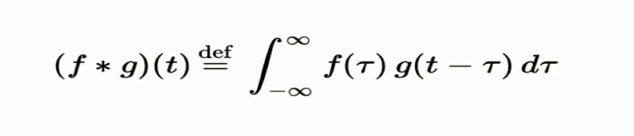](http://www.superdatascience.com/wp-content/uploads/2018/08/Convolutional_Neural_Networks_CNN_Step1_Img1.png)**Convolution is a function derived from two given functions by integration, which expresses how the other modifies the shape of one. That can sound baffling as it is, but to make matters worse, we can look at the convolution formula:

Convolution operation works using these 3 elements

* Input image
* Feature Detector
* Feature map

Input image: As humans, computers cannot see the image as it is, images are nothing but a pixel value for the computer. Consider the following image as an example

We can see this as a smiling face but computer will see this image as a pixel matrix. Computer will see this image as

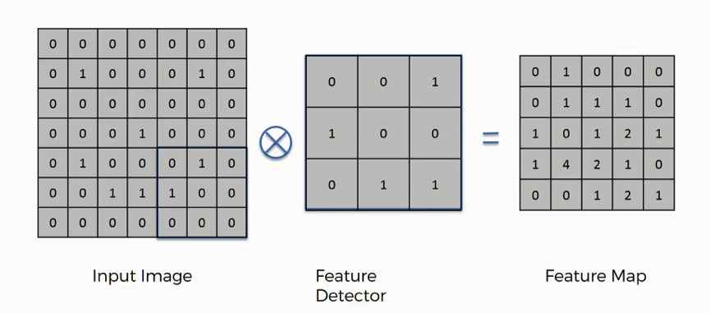

With 1 representing value is present and 0 representing absence of the value.

Feature Detector: It is simply a feature matrix, which compare for a specific feature in the image matrix depending on the image size and task we can create the feature detector for this example we will consider 3*3 feature detector which is more conventional, it is often referred as filter. We can show the process as

Figure – Convolutional Operation

Feature map:

It is the product of image matrix and feature detector matrix. As shown in the above figure.

2. MAX POOLING

In this step, we enable the convolutional neural network to detect the required pattern from the image when presented in any manner like different viewing angle, lightening condition, etc. In order to perform pooling, we must finish convolution operation first, so that we will have feature map ready.

In this we pool out the max values from the feature map using some fixed pixel strides (2*2 pixel strides are shown in the example below) and creates new pooled feature map.

**[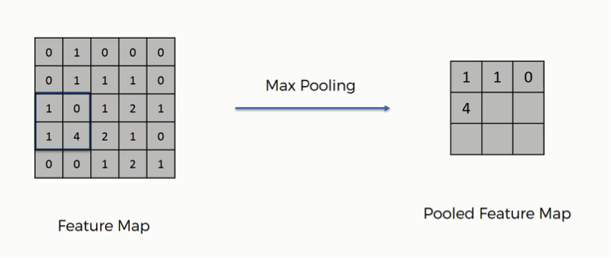](http://www.superdatascience.com/wp-content/uploads/2018/08/Convolutional_Neural_Networks_CNN_Step2_Img3.png)**1.2.1Pooled Feature Map:

Figure – Max Pooling

Similar to convolution step, pooling disposes the unnecessary information or features from the original input and gives the optimized patterns.

1.3 Flattening

As the name suggest, we literally flatten our pooled feature map into a vector as shown in the image below.**[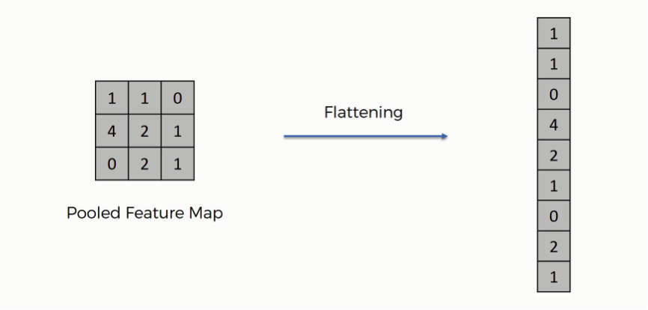](http://www.superdatascience.com/wp-content/uploads/2018/08/Convolutional_Neural_Networks_CNN_Step3_Img1.png)**

Figure- Flattening of pooled feature map

**[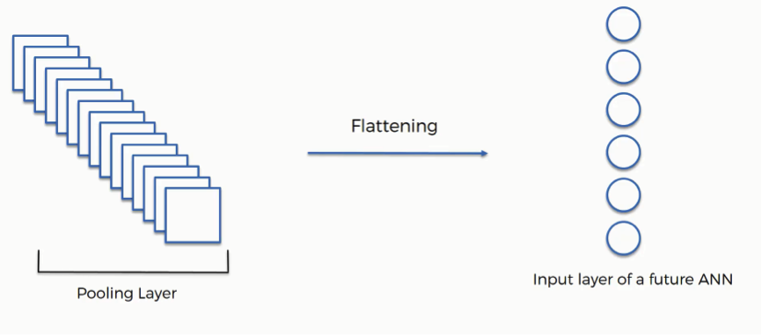](http://www.superdatascience.com/wp-content/uploads/2018/08/Convolutional_Neural_Networks_CNN_Step3_Img2.png)**We perform flattening because we have to insert this data into an artificial neural network in the next step. As we have many pooled layers we flatten all these in into a vector and pass this vector as a input to the neural network for further processing.

Figure – Inserting data into NN

* 1. FULL CONNECTION

This is the step where we connect our convolution layer to our artificial neural network and create the Convolutional Neural Network. Neural network takes this data as input, learns the various features, patterns, attributes and combine them to wider attributes to classify the images.

References

[1] https://www.med.upenn.edu/sbia/brats2018/data.html